

**Department of Computer Science and Engineering**

**Fall 22**

**Project Report**

**Course Code:** CSE 209

**Section:** 05

**Topic Name:** Voltage Divider and Selector Circuit

**Group No:** 03

**Submitted by:**

|  |  |
| --- | --- |
| **Name** | **ID** |
| Dilruba Akter | 2021-3-60-077 |
| Ahnaf Shahadat Taseen | 2021-3-60-043 |
| Tanvir Ahmed Ratul | 2021-3-60-140 |
| Sagor Shaha | 2021-3-60-166 |

**Date of Submission:**

**3/1/2023**

**Problem Discussion:**

A 10V DC supply is available. In practice you need to use 10V, 5V, and 3V as supply voltage of a low

Current electrical circuit. Design a voltage divider circuit so that the desired voltage can be selected at the

Output.

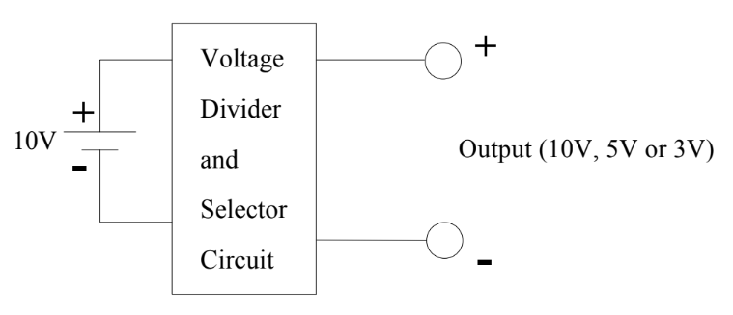

**Design:**

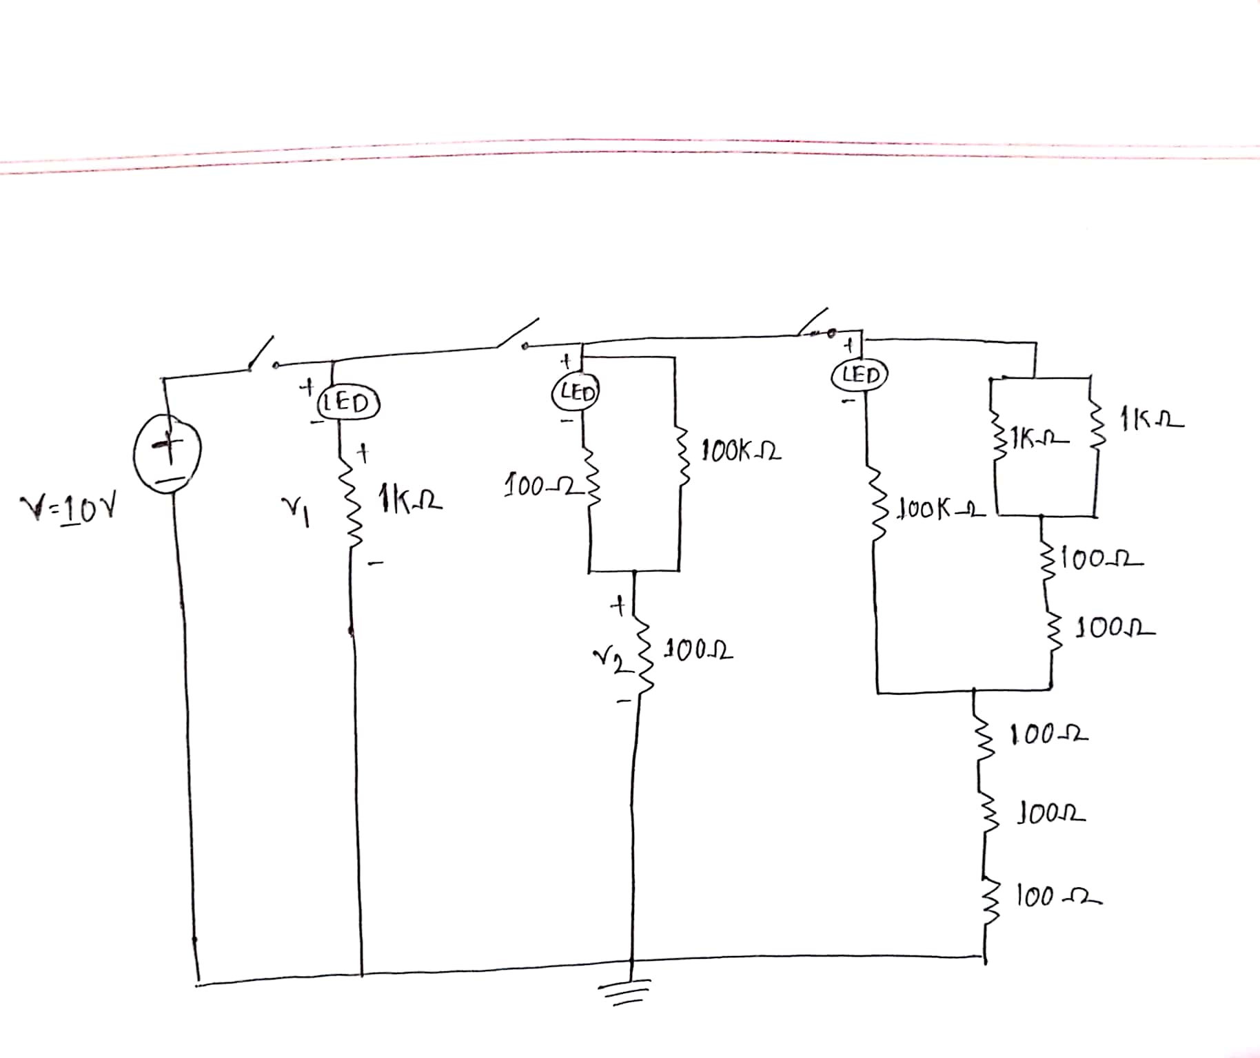

**Calculation:**

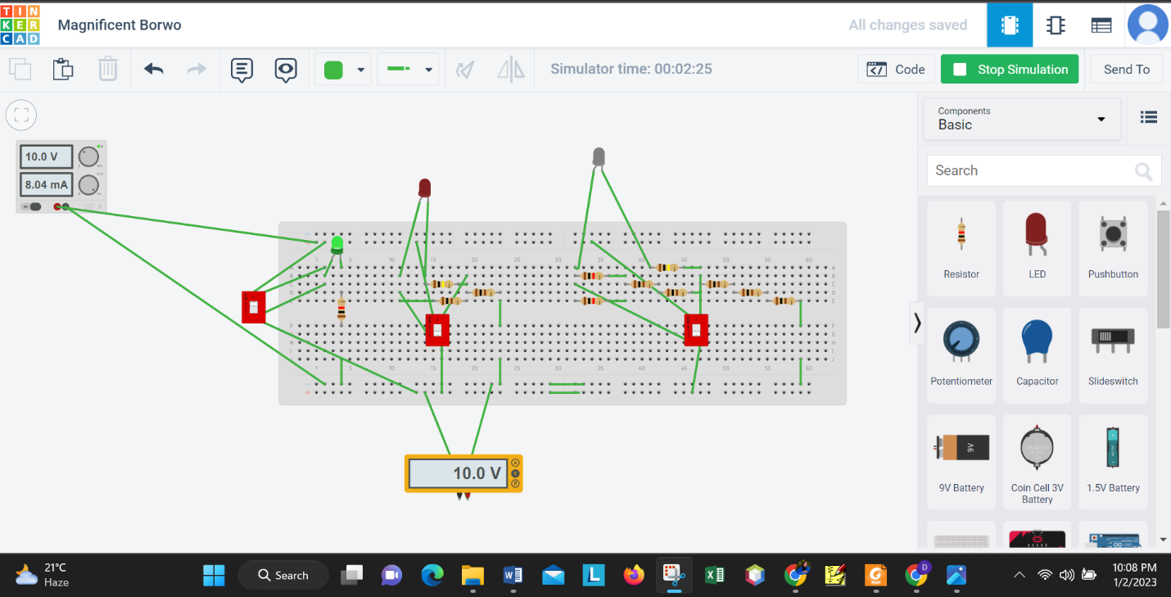

Here,

Since, 1K Ω is parallel therefore 10V will be across the 1K Ω.

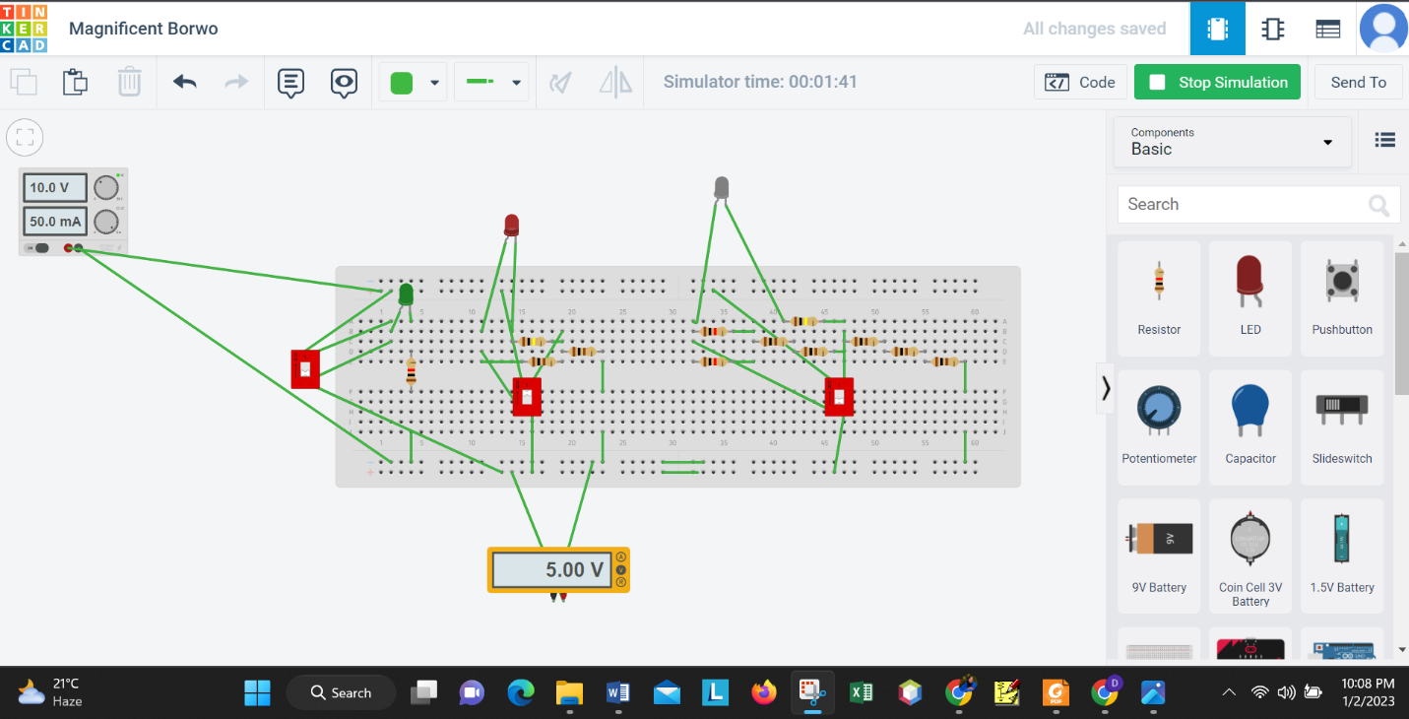

For V2 = V

= 5.00 V

So, 5V will be across 100 Ohm resistor.

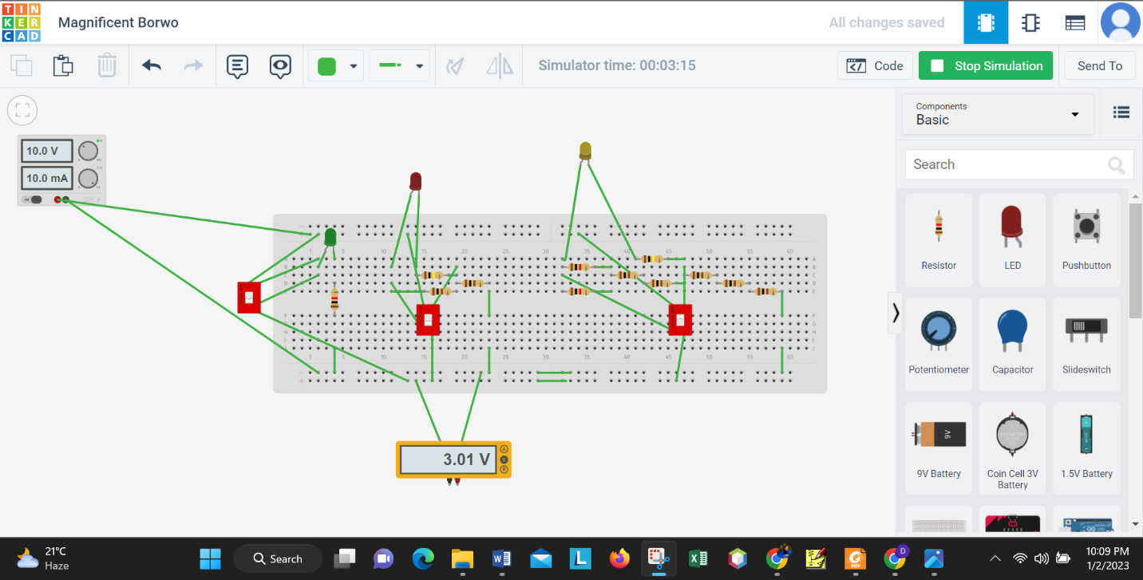

Again,

Rs = R10 + R11 + R12 = 300 Ω;

Rp1=

= 0.5k = 500 Ω

Rp2 =

= 695.134 Ω

Now, V3 = V

= 3.015 V

So, 3V will be across Rs.

**Experimental Data (for 10V):**

|  |  |  |  |  |
| --- | --- | --- | --- | --- |
| Measured Value of V (V) | Measured Value of V1(V) | Measured Value of V2 (V) | Measured Value of V3 (V) | Measured Value of Resistances (Ω) |
| 10.41V | 10.13V | 5.12V | 3.08V | R1= 1K  R2= 100K  R3= 98.5  R4= 98.7  R5= 97.8  R6= 1K  R7= 0.99  R8= 98.8  R9=  98.7  R10= 98.7  R11= 98.5  R12= 98.4 |

Our circuit is designed to give a 5V and a 3V output from a 10V supply. Due to some error in the lab, a 9V battery was used instead of the on 10V supply, resulting in our values ​​of v2 and v3 being much lower than five volts and three volts.

|  |  |
| --- | --- |
| **For 10V we get** | **For 9V get** |
| V= 10.41 | V= 8.93 |
| V1 = 10.13 | V1 = 8.02 |
| V2 = 5.12 | V2 = 4.42 |
| V3 = 3.08 | V3 = 2.75 |

From the previous diagram if the value of R3 is taken to at 80 Ohm, we will get 5V across 100 Ohm. And if we remove R8 from our circuit then we will get 3V across 300 Ohm.

|  |  |
| --- | --- |
| **Simulated Value For 10V (V)** | **Measured Value(V)** |
| V= 10 | V= 10.21 |
| V1 = 10 | V1 = 10.03 |
| V2 = 5 | V2 = 5.12 |
| V3 = 3.01 | V3 = 3.23 |

|  |  |
| --- | --- |
| **Simulated Value For 9V (V)** | **Measured Value(V)** |
| V= 9 | V= 8.93 |
| V1 = 9 | V1 = 8.02 |
| V2 = 5 | V2 = 4.42 |
| V3 = 3 | V3 = 2.75 |

**Conclusion:**

In this project, For simulation we used tinkercad website. From the table 2 we see that our theoretical value and measured value are not equal. We found this difference because of the temperature of the room where we did our experiment. Also we had to be careful not to flow too much current through the LED because the highest current through the light is 20mA. If the current through the LED is greater than 20mA then our LED light would burst.